**DOMAIN MODEL**

**Table of Contents:**

Summary(Revised) Page 1

Domain Model Diagram(Revised) Page 2

Glossary (Revised) Page 3

**Summary (REVISED)**

Following in this document is our domain model. It shows how our interfaces are linked together and what interactions they take between each other. The various functions and variables are all described. Our interfaces are: Game, Player, Resource, Building, HighScore and Login. Login is the only real stub class, as it deals with an outside interface to validate.

**Domain Model (REVISED)**

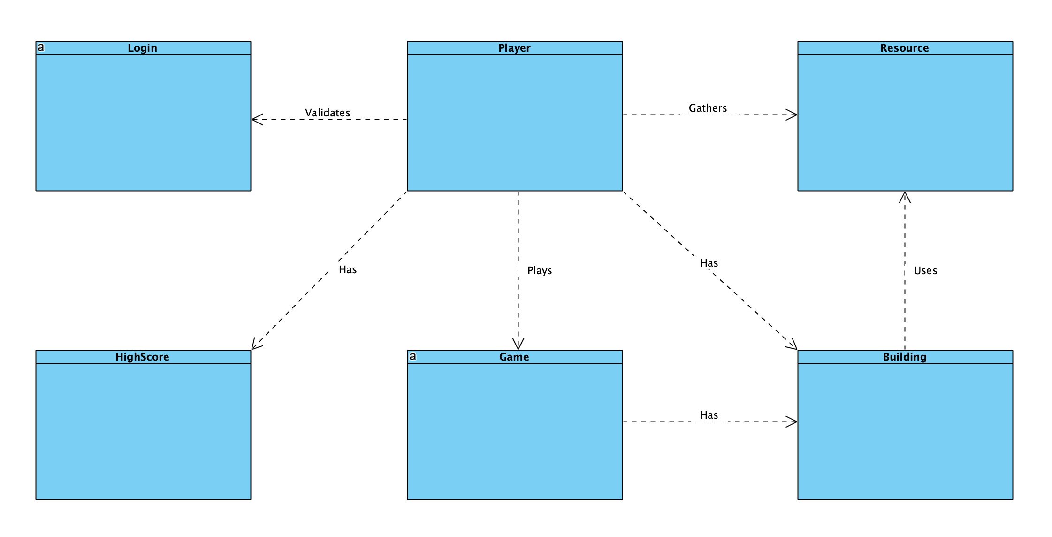

* The concept of the system runs through the actions of a user. For the system to operate, the user must go through each iteration of the system requirements to play. The user must log in, gather a resource, build on game board, and have the game permission to build.
* The game interface is responsible for assigning the values to the buildings that uses resources and holds the various buildings for the player to use.
* The player interface is one with multiple relationships in which all may not depend on each other, but have a common relationship. Player must be validated with a log in, which allows the player to play on the game by building with resources gathered, which are then approved by the game class.

**GLOSSARY (REVISED)**

|  |  |  |  |
| --- | --- | --- | --- |
| Term | Definition | Validation Rules | Relationships |
| Player | A person who plays the game. Is able to take actions and win the game. | Has an authenticated log in | Login, Resources, Game, HighScore |
| Login | User created ID and password to play game. | Must be an appropriate non-used  ID. | Player |
| Resources | Objects uniquely assigned to a player, used for building structures | N/A | Buildings, Player |
| Game | Class that administers and defines objects and actions taken by User/Player. | Must be run on a device. | Player, Buildings, High Score |
| HighScore | Contains the high score and accessed to compare score | Must have some high score existing | Game, Player |
| Building | Structure built by player using resources. | Game validates appropriate amount of resources available. | Resources, Game |